**Assignment Subjective Question & Answers:**

1. **Which are the top three variables in your model which contribute most towards the probability of a lead getting converted?**

**Answer:**

Below is the graph of relative importance of different features based on their

coefficient values in the model:

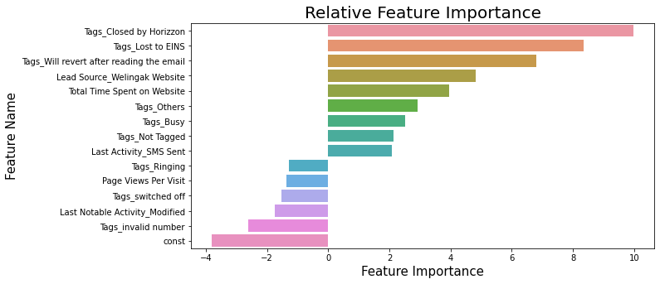

According to the above graph, there are three variables that have the most significant impact on the likelihood of lead conversion. These variables are created as dummy features from the categorical variable Tags and are ranked in decreasing order of impact:

* Tags_Lost to EINS
* Tags_Closed by Horizon
* Tags_will revert after reading the email

All of these features have a positive impact on the probability of lead conversion. Therefore, the company should focus more on leads that have these three specific tags.

窗体底端

1. **What are the top 3 categorical/dummy variables in the model which should be focused the most on in order to increase the probability of lead conversion?**

**Answer**:

From the graph above, the top 3 categorical/dummy variables in the model which should

be focused the most on in order to increase the probability of lead conversion are:

* Tags_Lost to EINS
* Tags_Closed by Horizon
* Tags_will revert after reading the email

Answer to both the questions is same because the top 3 variables in the model are all

categorical/dummy variables.

1. **X Education has a period of 2 months every year during which they hire some interns. The sales team, in particular, has around 10 interns allotted to them. So during this phase, they wish to make the lead conversion more aggressive. So they want almost all of the potential leads (i.e. the customers who have been predicted as 1 by the model) to be converted and hence, want to make phone calls to as much of such people as possible. Suggest a good strategy they should employ at this stage.**

**Answer:**

Here, the concept of sensitivity is required.

For our model, below is the graph showing changes in Sensitivity, Specificity and Accuracy with change in the threshold:

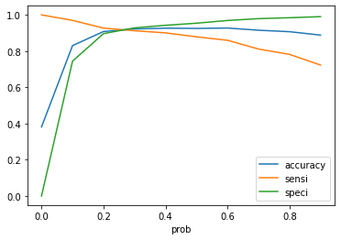

* **Conclusion**:To increase the probability of lead conversion, X-Education can target leads that spend a lot of time on their site, have repeated visits, and have come through references as they are more likely to convert. However, interns should highlight X-Education's competitive advantages during repeated visits. Although students may have a lower probability of converting, targeting them can ensure industry readiness upon completion of their education.

1. **Similarly, at times, the company reaches its target for a quarter before the deadline. During this time, the company wants the sales team to focus on some new work as well. So during this time, the company’s aim is to not make phone calls unless it’s extremely necessary, i.e. they want to minimize the rate of useless phone calls. Suggest a strategy they should employ at this stage.**

**Answer:**

* Avoid targeting unemployed leads who may not have the budget to spend on courses. Similarly, avoid targeting students who may not be willing to enroll in industry-based courses for working professionals early in their tenure.